**Ansible qs 2**

**Step1: create a playbook file**

**Update-packages.yml**

- name: Update all packages on Ubuntu hosts

hosts: all

become: true

tasks:

- name: Update package list and upgrade all packages

apt:

update_cache: yes

upgrade: dist

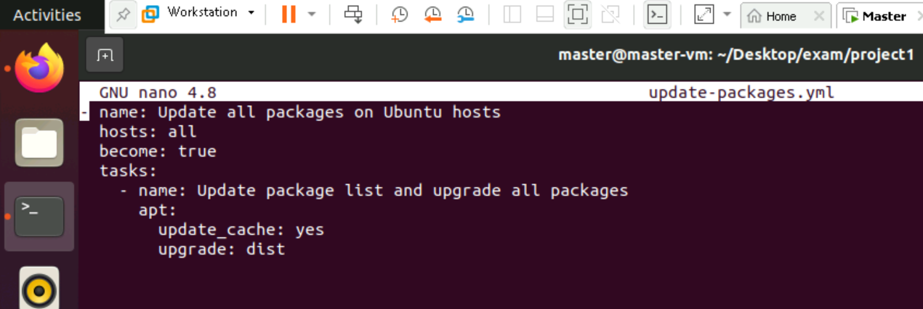

**Step2:**

**Run the play book using the command:**

ansible-playbook -i hosts.ini update-packages.yml –ask -pass --ask-become-pass

